
Title / Question

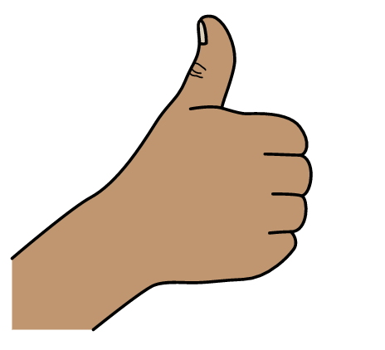
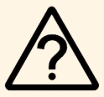
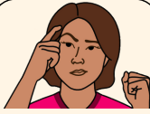


Positive Label (i.e., good)

Not Sure

Negative Label
(i.e., bad)
I do not know what this means





Label

Label

Label

Label





Label

Label

Label

Label





Label

Label

Label

Label





Label

Label

Label

Label

